1. Project Overview
Project Title - Personal Finance Manager using Python
Project Description
The Expense Tracker is a Python-based command-line application designed to help users record, manage, and analyze personal expenses efficiently. The project uses CSV files for data persistence, follows a modular architecture, and provides reporting, validation, backup, and restore features.
Project Goals & Objectives
- Record expenses with amount, category, date, and description
- Store expense data persistently using CSV files
- Provide an interactive, menu-driven command-line interface
- Ensure strong input validation and error handling
- Generate expense reports (total, average, category-wise)
- Implement data backup and restore functionality

2. Setup Instructions (Installation & Configuration)
System Requirements
- Operating System: Windows / Linux / macOS
- Python Version: Python 3.8 or above
Installation Steps
- Install Python from the official website
- Verify Python installation:
- python --version
- Download or copy the project folder
- Open terminal / command prompt
- Navigate to the project directory:
- cd Finance Manager
- Run the application:
- python main.py
Configuration
- No external libraries required
- CSV files are automatically created on first run

3. Code Structure
File Hierarchy
Finance Manager /
- main.py # Program entry point
- expense.py # Expense class definition
- utils.py # Command-line menu system
- file_handler.py # CSV file operations
- validation.py # Input validation functions
- reports.py # Expense report generation
- backup_restore.py # Backup and restore logic
- data/expenses.csv # Expense data storage
- backup/ expenses_backup.csv # Backup file
Design Approach
- Modular structure
- Separation of concerns
- Easy to maintain and extend

4. Technical Details
Algorithms Used
- Summation Algorithm – total expense calculation
- Average Calculation – mean expense value
- Grouping Algorithm – category-wise expense aggregation
Data Structures
- Class (Expense) – stores individual expense data
- Lists – store multiple expense records
- Dictionaries – category-wise expense totals
Architecture
- CLI-based application
- Layered design (UI → Logic → Data)
- CSV-based persistence
Error Handling
- Try–except blocks for:
  - Invalid numeric input
  - Incorrect date formats
  - File read/write errors
5. Visual Documentation
- Main menu screen

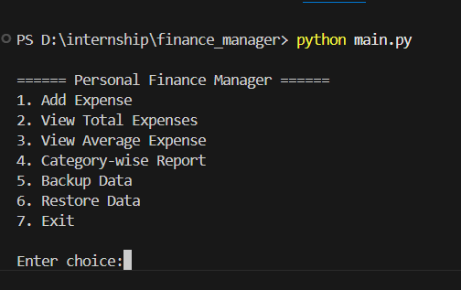

- Adding a new expense

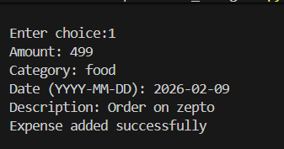

- Displaying expense list



- Report generation output

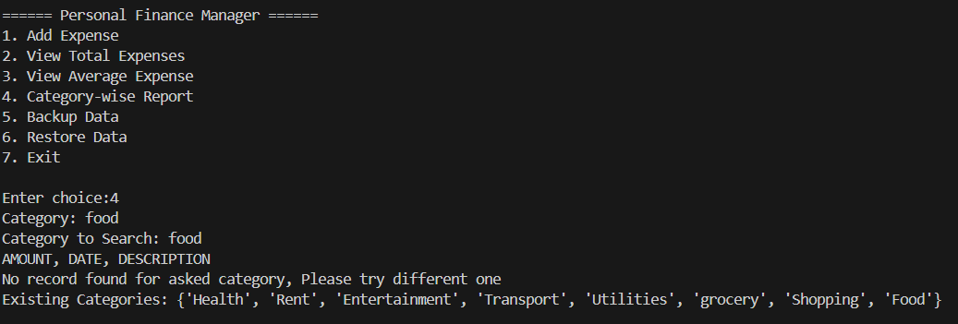
- Backup success message

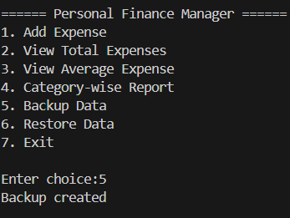

- Restore confirmation

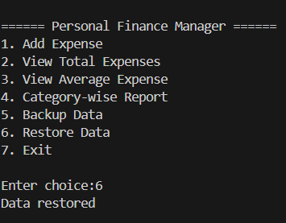

6, Testing Evidence (Test Cases & Validation)
Sample Test Cases
Test Case | Input | Expected Result
Invalid amount | abc | Error message shown
Negative amount | -50 | Rejected
Invalid date | 12/45/2024 | Format error
Empty category | blank | Prompt again
CSV file missing | Delete file | Auto-created
Restore backup | Valid backup | Data restored

Validation Techniques
- Numeric validation for amount
- Date format validation (YYYY-MM-DD)
- Non-empty string validation
- File existence checks
Result
All test cases pass successfully, ensuring reliability and correctness

